1. For **EID request** initiate by **Shanmuk**.
2. **Mail id** initiate by **Shanmuk**
3. Check with **global IT Honeywell** for the status of mail by contacting **0008000501866,** if number is changed go to **First Floor Honeywell IT solutions** and get the new no.
4. Raise VPN request once EID and email id created (IT solution), For that contact **HCL global IT** for temporary admin credentials by contacting **0008000501866.**
5. Send request for DEV 1 & VM by following **step 8 & 9.**
6. Once VM is accessible ask Shanmuk to raise a request to install flare in VM.
7. Send request for Siebel Access.
8. For **Dev 1** access request

click <https://wiki.honeywell.com/display/acsInfoDev/New+Starter+Orientation+Checklist>

1. Go to 2nd tab, if you are unable to open this page, contact **Patricia.Scott** (skype).

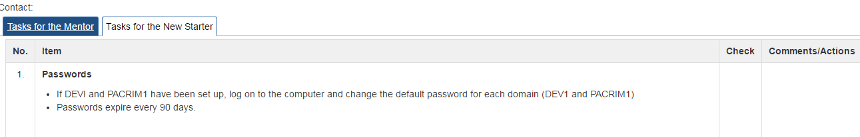

1. Follow point number 5 and request **for DEV1 Access to ID-related servers**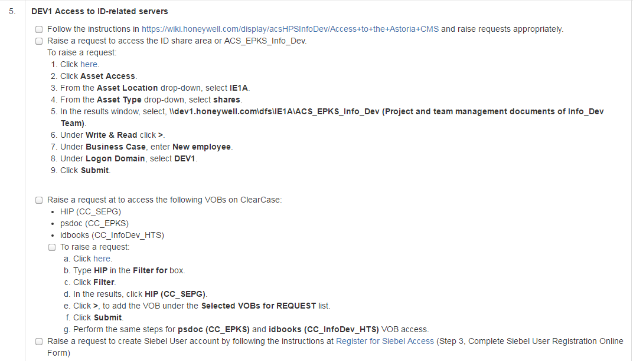
2. Follow same process as shown in **step b** **(Follow point 5 for DEV1 Access to ID-related servers) and raise a request for global as well.**

* **In step 8, instead of DEV 1 select Global under Logon domain**

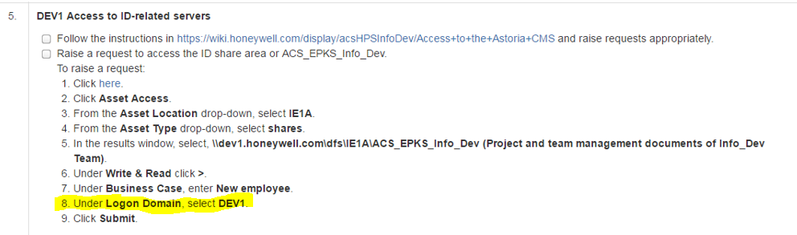

**Procedure to submit the access request for Win10 VM in BLR DEV1:**

1. Open the link: <http://access.dev1.honeywell.com/dev1_requests/Asset_Access.aspx>
2. Select the asset location as “IE1A” and Asset type as “pcoip”
3. Filter  “pool-1-HIP Only”
4. Select the “pool-1-HIP Only” and move (by using arrow “>”) it to “Write & Read” box
5. Write Business Case as “**Migrating to Win10 Platform** “
6. Select the logon Domain as DEV1
7. VM ware access
8. If VM ware access request approved, will get the following email

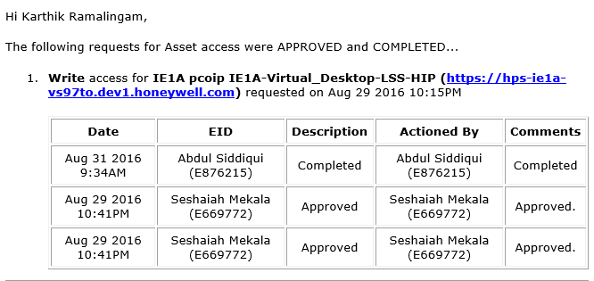

1. Open VM ware application and enter “**hps-ie1a-vs97to.dev1.honeywell.com**” to server name.

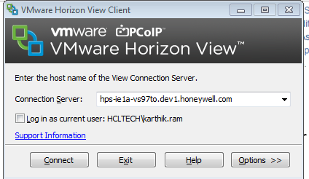

1. Login to VM ware using Dev1 credentials

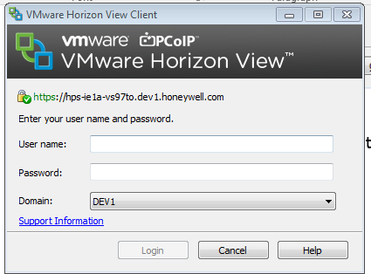

For SIEBEL Access NEW USER REGISTRATION

1. Please use the following website for new user registration:

<https://honeywellprod.sharepoint.com/teams/hps-crm-application/default.aspx>

1. After clicking on it, navigate to the bottom side of the screen and click on “Apply for ACE CRM access (New User Registration).

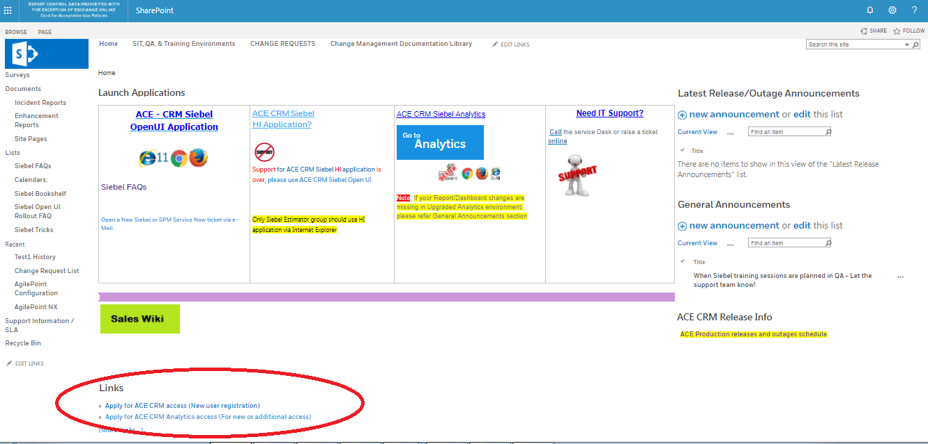

1. On clicking the link, user will be redirected to the following page. On this page, click on “**I Accept**” and then click on “**+**” Button on top right and enter you EID (ex.E123456). Click on “**GO**”.

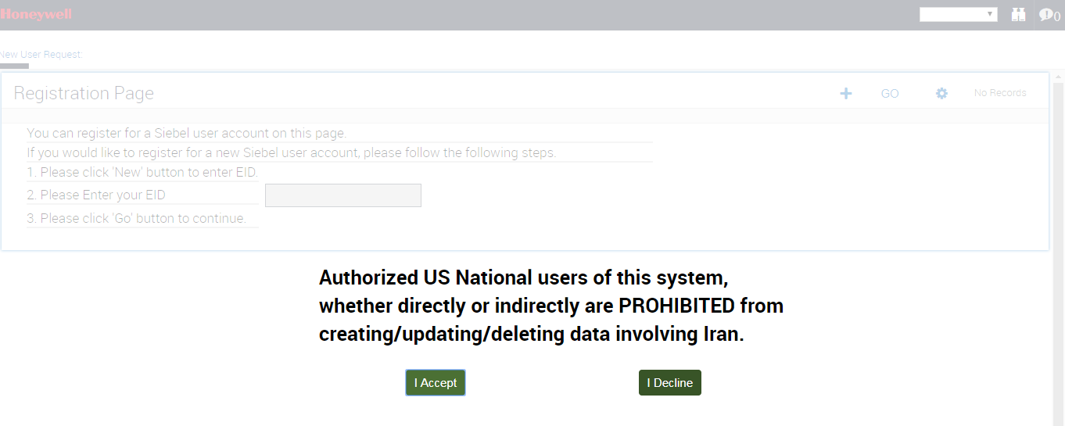

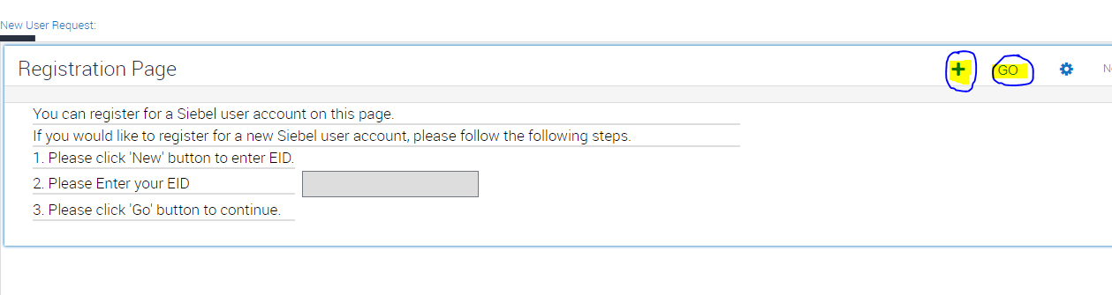

1. Fill all the Mandatory details required, do not forget to fill “**Honeywell Facility**”. After filling the form, submit the request. You will receive a **Request_Id** and that request will go to your **Manger** initially then by **Data Steward** for approval.
2. You can access Siebel once your **Manager** and **Data steward** approves your request. You can connect directly with Data Steward for your access.   
     
   **Below are the details for Data Steward:**  
   APAC region: HPS CRM DST – APAC ([hpscrmdst-apac@honeywell.com](mailto:hpscrmdst-apac@honeywell.com)) or Pobbathi, Bhargavi (Bhargavi.Pobbathi@Honeywell.com)

AMER region: HPS CRM DST – AMER ([hpscrmdst-amer@honeywell.com](mailto:hpscrmdst-amer@honeywell.com)) or Nath, Jyoti (Jyoti.Nath@Honeywell.com)  
  
EMEA region : HPS CRM DST – EMEA ([hpscrmdst-emea@honeywell.com](mailto:hpscrmdst-emea@honeywell.com))

1. If you are facing any issue while raising this request, please connect with **Siebel Team**DL-PMT Siebel CRM Support Team ([DL-PMTSiebelCRMSupportTeam@Honeywell.com](mailto:DL-PMTSiebelCRMSupportTeam@Honeywell.com))
2. For Collaborator Access

Follow the instructions in the below link and raise request appropriately.

<https://honeywellprod.sharepoint.com/teams/HIP-Tools/Collaborator/SitePages/Request%20Access.aspx>

1. Links

Bitbucket: <https://bitbucket.honeywell.com/projects/GIIDOC>   - Ask Shanmuk to provide the access

Jira: <https://acsjira.honeywell.com/secure/RapidBoard.jspa?projectKey=REXPDOC&rapidView=9797&view=planning> – Raise IT ticket to get the access (IT Direct).

Honeywell process.com: <https://www.honeywellprocess.com/en-US/pages/default.aspx>

process.honeywell.com

Tacdb for PAR: <http://tacdb.iac.honeywell.com/>

Vault: - NA  
<http://hpsvault.honeywell.com/sites/HPSVaultSupportLibrary/Documents/Forms/HPS%20Vault%20View.aspx?InitialTabId=Ribbon%2EDocument&VisibilityContext=WSSTabPersistence>

IT Direct: <https://honeywell.service-now.com/itdirect>

Siebel: <https://hpscrm.honeywell.com/service_enu/start.swe> or <https://hpscrm.honeywell.com/service_enu_oui/start.swe?SWECmd=Login&SWECM=S&SRN=&SWEHo=hpscrm.honeywell.com>

Confluence- ask shanmuk